PMG201c.PE2_E-Commerce Website for Small Businesses
Given the context for the project as following, you are the PM for this project
A company is launching a multi-vendor e-commerce platform for small businesses. The platform must provide:
- User registration for businesses to create their online stores.
- Payment integration with multiple payment providers.
- Product listing and order tracking features.
- Customer review system for feedback and ratings.
The website must support up to 10,000 vendors and 100,000 daily transactions. The project has 6 months to launch its first version, with a budget of $800,000.
Request 1 (weight 15%)
Define at least 2 project objectives using SMART criteria (objectives that are Specific, Measurable, Achievable, Relevant, and Time-bound, ensuring clarity, trackability, and focus for achieving desired outcomes).
Request 2 (weight 25%)
Define the scope for this project which include in-scope items, exclusive (or out-of-scope) items, and the deliverables that you would need to provide for the project.
Request 3 (weight 25%)
Define at least 5 quality assurance (QA) or quality control (QC) activities for the project. For each activity, you need to classify it as QA or QC and give relevant detailed descriptions (which describe the purpose, when and how to do).
Request 4 (weight 35%)
Assume that you have defined and estimate schedule for one of main project deliverables with below high-level activities as following:
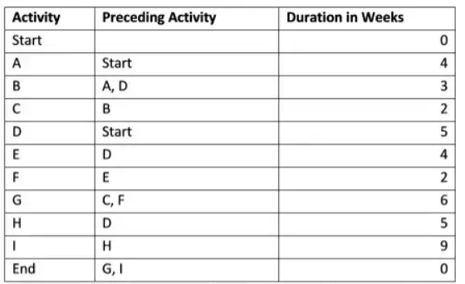
a. What are paths in the network diagram for the deliverable?
b. Identify the minimum duration to complete that deliverable?
c. What are activities which have the most flexibity (in term of time)?
d. In the 8th week, you are executing the activity D and found that you need to speed up the project schedule to recover 3-week delay. Define at least four solutions with relevant explanation and assumptions (if needed) to achieve that

